**DAILY ONLINE ACTIVITIES SUMMARY**

|  |  |  |  |  |  |  |  |  |
| --- | --- | --- | --- | --- | --- | --- | --- | --- |
| **Date:** | **02-06-2020** | | | | | **Name:** | **Anix Jugal D’Cunha** | |
| **Sem & Sec** | **8 sem , A sec** | | | | | **USN:** | **4al16cs013** | |
| **Online Test Summary** | | | | | | | | |
| **Subject** | | **Not Conducted** | | | | | | |
| **Max. Marks** | | **-** | | **Score** | | | **-** | |
| **Certification Course Summary** | | | | | | | | |
| **Course** | **Steps into Robotic Process Automation** | | | | | | | |
| **Certificate Provider** | | | **GUVI’s RPA** | | **Duration** | | | **4 hours** |
| **Coding Challenges** | | | | | | | | |
| **Problem Statement:** C program for inversion count of array | | | | | | | | |
| **Status: Completed** | | | | | | | | |
| **Uploaded the report in Github** | | | | | **yes** | | | |
| **If yes Repository name** | | | | | **alvas-education-foundation/dcunhaanixjugal** | | | |
| **Uploaded the report in slack** | | | | | **yes** | | | |

Online Test Details: (Attach the snapshot and briefly write the report for the same)

Not conducted

Certification Course Details: (Attach the snapshot and briefly write the report for the same)

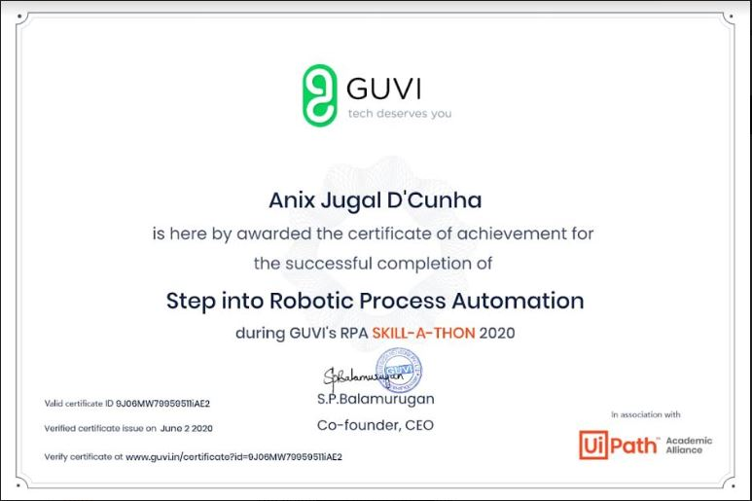

Coding Challenges Details: (Attach the snapshot and briefly write the report for the same)

Program 🡪 C program for inversion count of array

|  |
| --- |
| #include <bits/stdc++.h> |
|  | int getInvCount(int arr[], int n) |
|  | { |
|  | int inv_count = 0; |
|  | for (int i = 0; i < n - 1; i++) |
|  | for (int j = i + 1; j < n; j++) |
|  | if (arr[i] > arr[j]) |
|  | inv_count++; |
|  |  |
|  | return inv_count; |
|  | } |
|  |  |
|  | /* Driver progra to test above functions */ |
|  | int main(int argv, char** args) |
|  | { |
|  | int arr[] = { 1, 20, 6, 4, 5 }; |
|  | int n = sizeof(arr) / sizeof(arr[0]); |
|  | printf(" Number of inversions are %d \n", getInvCount(arr, n)); |
|  | return 0; |
|  | } |